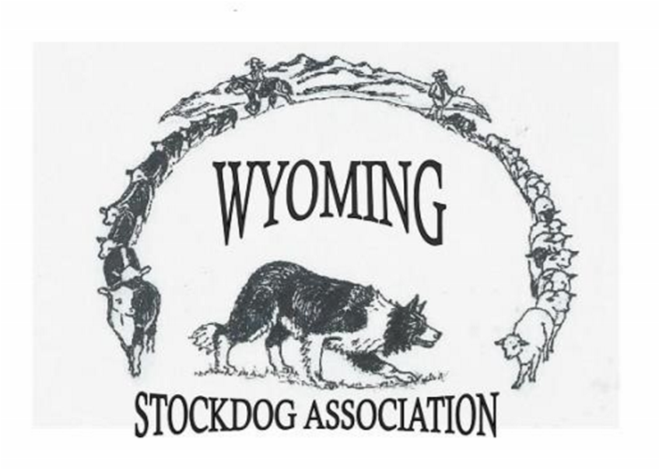
WSDA WRIGHT WINTER TRIAL #1
Saturday, December 12th, 2026: Judged – Start Time 9 a.m.
Run Order: Open, Nursery, Open Ranch, Ranch Class, Novice
Sunday, December 13th, 2026: Judged – Start Time 9 a.m.
Run Order: Novice, Ranch Class, Nursery, Open Ranch, Open
Open and Nursery USBCHA Sanctioned Both Days
Location: Southern Campbell County Ag Complex -
220 Prospector Drive – Wright, Wyoming
E-mail entries to: wystockdogassociation@gmail.com
Mail to: Cheryl Barker – 80 Owl Creek Rd– Sheridan, WY 82801 – (307)751-3640 Make checks payable to: Wyoming Stock Dog Association (WSDA)
ENTRIES OPEN NOV 10TH & CLOSE DEC 5TH, 2026. Payment can be made day of trial.
Dog | Open 1 $40 | Open 2 $40 | Nursery 1 $40 | Nursery 2 $40 | OR 1 $40 | OR 2 $40 | Rnch  1  $40 | Rnch  2  $40 | Nov  1  $30 | Nov 2  $30 | Total
 |  |  |  |  | WSDA NON-MEMBER PROCESSING FEE DAY 1 |  |  |  |  |  | 10.00
 |  |  |  |  | WSDA NON-MEMBER PROCESSING FEE DAY 2 |  |  |  |  |  | 10.00
 |  |  |  |  | TOTAL
Nursery Age Requirement: Any dog born on or after July 1, 2024 is eligible for the 2027 USBCHA Finals. *Please provide some form of validation for nursery entries, thank you
Handler Name: _____________________________________Telephone:__________________________
Address: City/ST/Zip: email:
READ AND SIGN: I agree to pay for all damages caused by my dogs or dogs under my control. I also agree that Wyoming Stock Dog Assn, and all trial affiliates (including but not limited to property owners, volunteers, sponsors) are not to be held liable for any damages to me, my dog(s) or dog(s) under my control. I also agree to pay the shepherds value for sheep damaged by my dog or dogs under my control.
Signature________________________________________________Date__________________________

