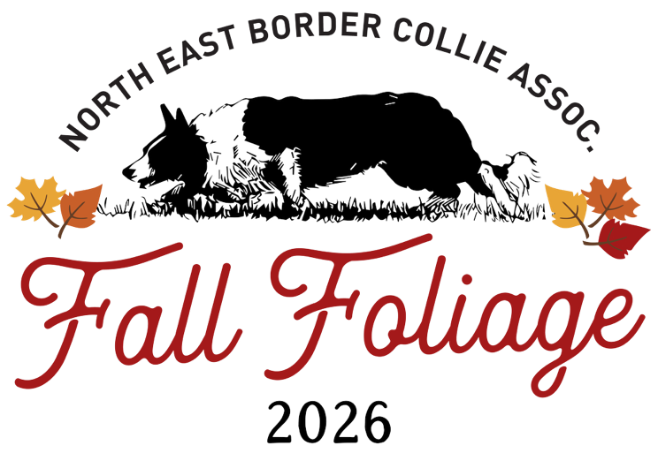
NEBCA Fall Foliage SDT
October 30 - November 1, 2026
Plantation Field, Coatesville, PA
USBCHA NEBCA Sanctioned
Judge: Chris Hicks

Two USBCHA- and NEBCA-sanctioned Open trials will be held on 10/30/26 and 10/31/26. Entries may be limited due to available daylight. On 11/1/26, a 15-team Double Lift Championship will be held. The finalists will include the five highest scores from Open 1, the five highest scores from Open 2, and the five highest combined scores. To be eligible for the Double Lift Championship, dogs must have NEBCA High Points for the trial season that ended on July 31, 2026, and handlers must be NEBCA members in good standing. The two Open trials are open to handlers who are not NEBCA members and to dogs without High Points.
Entries open on 9/1/26 and close on 9/15/26. All entries received during the entry period will be treated equally; early entry is accepted but does not guarantee a spot. Checks will be cashed, and no refunds will be issued after 9/15/26. If a draw is needed, information will be posted shortly after entries close. The running order will be drawn and posted the week before the trial.
Entry fees: $80 per Open trial. Please send a separate check for any third Open dog. Checks for third dogs will not be deposited if third dogs are not allowed.
Payment information: Checks only and they should be made payable to NEBCA.
Camping: Camping is available. No hookups are provided.
Directions: The trial will be held at Plantation Field, 347 Green Valley Rd., Coatesville, PA 19375.
Mail entries and checks to: Martha Walke, P.O. Box 66, South Strafford, VT 05070
For questions about entries, running order, worker schedule, or related details, contact Carolyn at 860-729-0550 (texts preferred) or tobyfwest@gmail.com.

NEBCA FALL FOLIAGE
October 30 – November 1, 2026
Handler’s Name: ___________________________________________________
Address: _________________________________________________________
Phone: ______________ Email: ____________________________

Entry Fees: $80 per Open run

Dog | Open 1 | Open 2 | 2026 NEBCA Points | Long Road Eligible? | Total

TOTAL ____________
ALL HANDLERS MUST SIGN IN AGREEMENT TO THE FOLLOWING:
In consideration of the acceptance of this entry to participate in the NEBCA Fall Foliage Sheep Dog Trial, I agree not to hold any organizer, sponsor, judge or volunteer of this trial, or the owners of Plantation Field , responsible for any injury or damage to myself, my property or my dog(s). I also agree to be responsible for the actions of myself and my dog(s) on and off the trial field. I will assume the financial responsibility for damages and veterinary care or replacement value of the stock ($350/ewe).
Signature: ________________________________________ Date: ________________

I would like to scribe ____ set sheep ____ work in the pen ____

