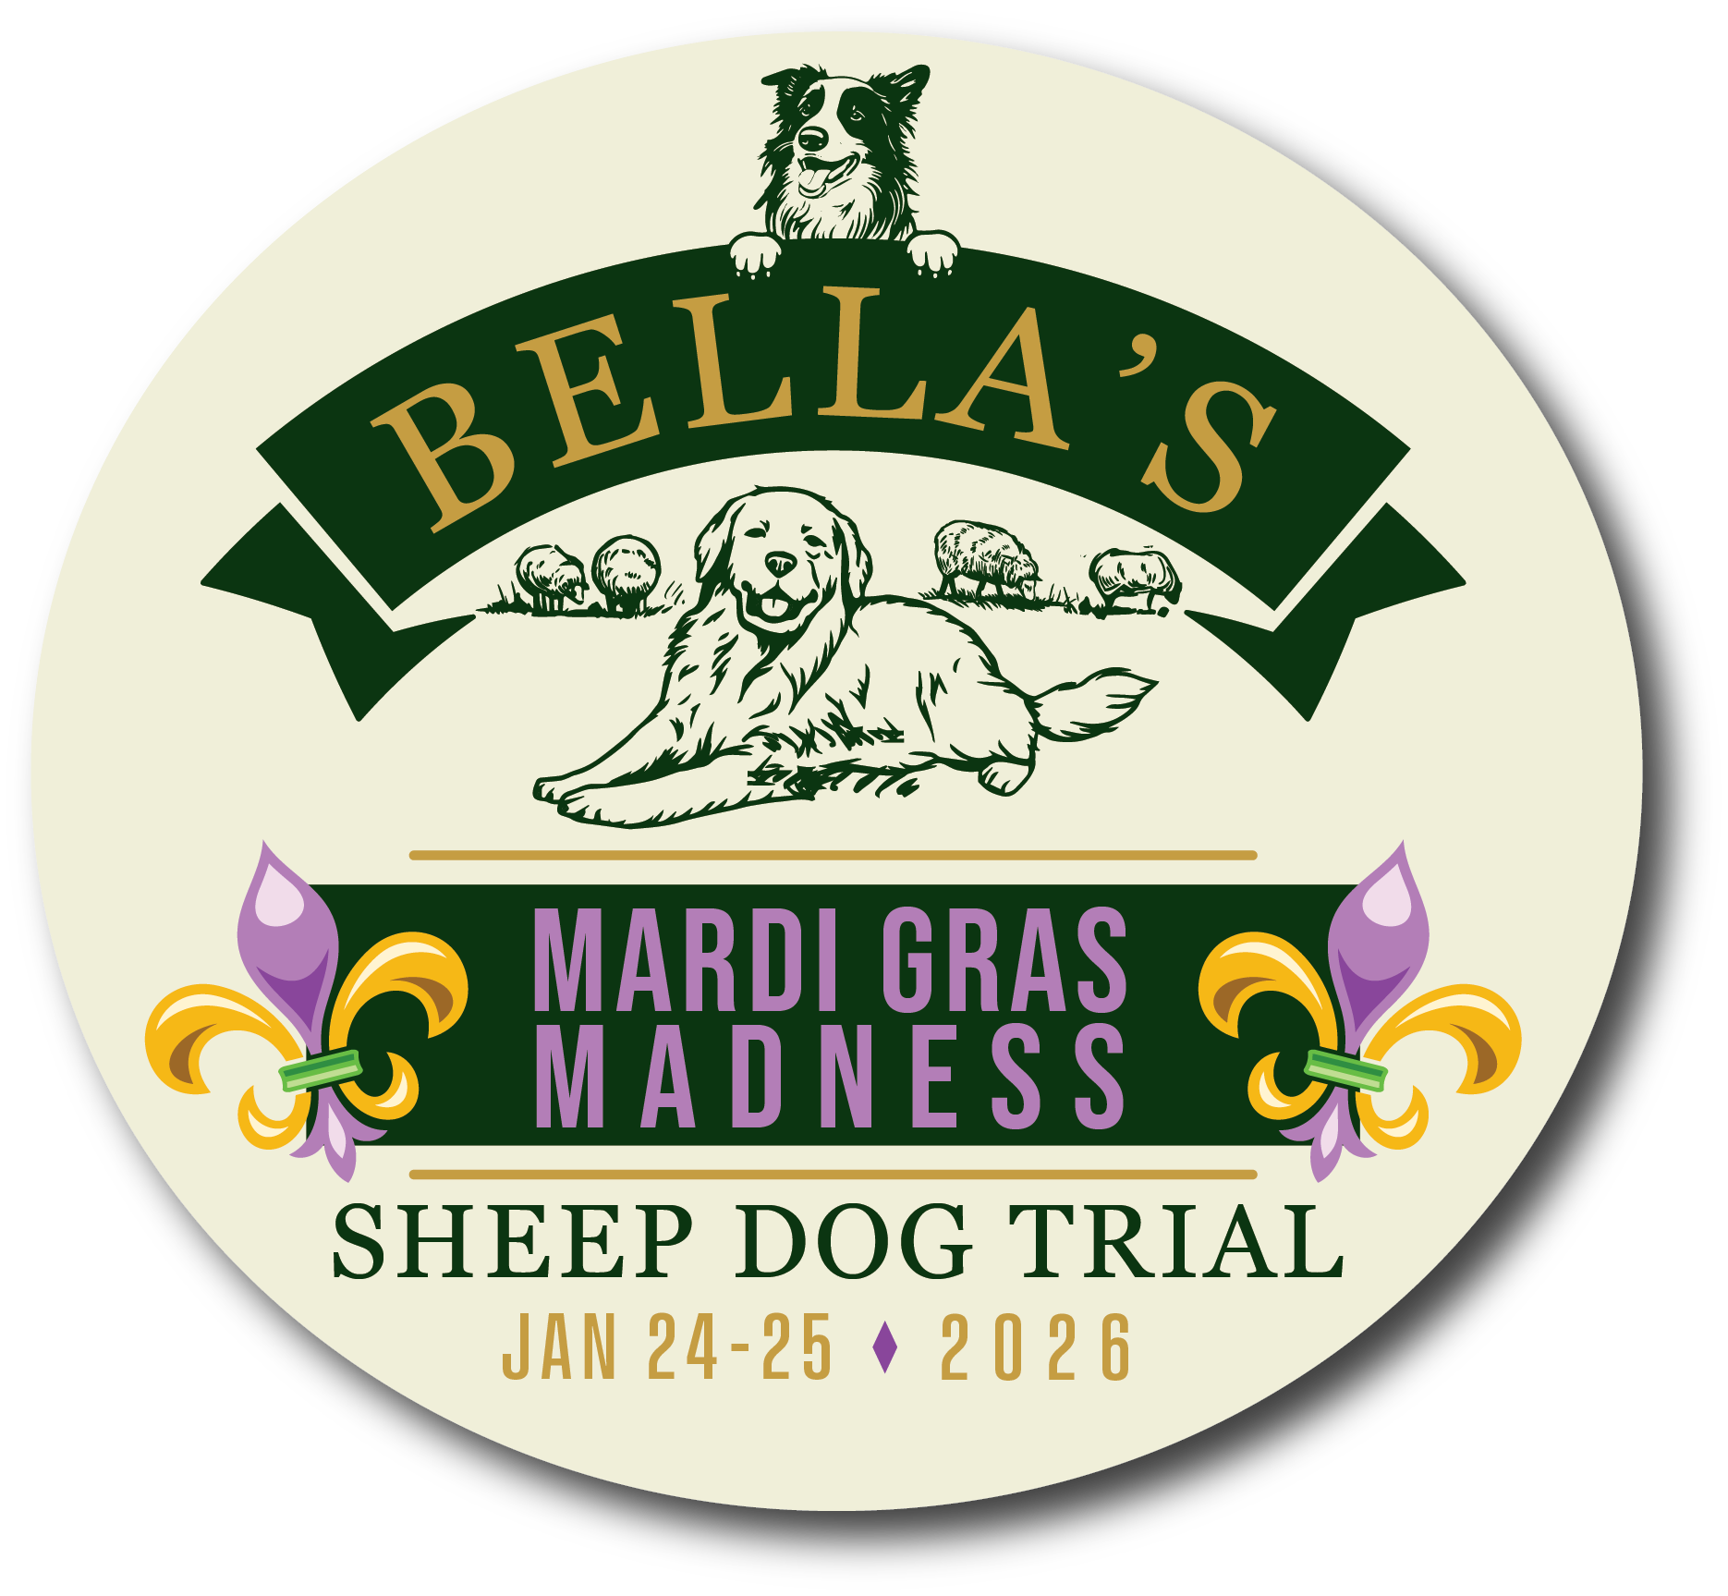

Bella’s Mardi Gras Madness Sheep Dog Trial
January 23, 24 & 25, 2026
Judge- Patrick Shannahan
Trial Host Jack Nofsinger/Penny Tose
Course Director-Diane Davis
Set-out-Adrian Espinoza
Trial Secretary – Diane Davis
USBCHA MSSDA, GSDA Sanctioned
3 Nursery, 3 Open Ranch
3 Pro-Novice, 3 Novice
Friday Handler’s meeting noon
Lessons w/Patrick Shannahan Monday,
January 26 schedule w/Jack

*Nursery- $60/run
(*Must have 5 for class, send
copy of papers)
Open Ranch –open course no shed- 250 yards $60/run
Pro-Novice –one panel drive $55/run
Novice –$45/run
Handler may walk with dog after gather
SILENT GATHER 400 YARD JACKPOT SATURDAY AFTER NOVICE $20 EACH Handler PAY ON SITE
Handler’s Pig Roast dinner Saturday night
USBCHA, MSSDA, GSDA sanctioned
Payback in all classes

Camping/Hotels
Ample Dry Camper Parking on site
Water available/Hotels in Wiggins,
Picayune, Hattiesburg, MS BringFido.com
Questions/information: Jack Nofsinger, 228-326-0008 j.nofsinger@icloud.com
Diane Davis 662-801-8882 pizzaprincess@mac.com
MAIL signed Entry Form & payment to: Fire Creek Farm 3936 Old Panola Rd Sardis MS 38666
Checks made out to Fire Creek Farm. No refunds after all checks cashed 1/16/26 No entry without signed entry from.
TRIAL LOCATION: Penny Tose Field, 1065 John Amacker Road, Poplarville MS 39

Bella’s Mardi Gras Madness 2026. Jan 23-25 Poplarville, MS

Entry Form Handler’s Name ____________________________
Trial Registration Opens (Post Marked) Dec 15 until full- No refunds after 1/16/26
I (We) certify that I (we) am (are) the owner or duly authorized agent of the owner(s), of the dogs, entered above. I (We) agree to hold Penny Tose, owner of the property where the trail is held, harmless from claim for loss or injury which may be alleged to have been caused directly or indirectly to any person, dog, stock or thing by the act of this dog(s), while in or upon the trial area near any entrance thereto, and I (we) assume all responsibility and liability for any such claim. I (We) further agree to hold the aforementioned parties harmless from any claim for damages or injuries to the dog(s) incurred due to aforementioned causes. In case of injury to any stock by the dog(s), I (We) will assume financial responsibility for any damages I (We) will pay the full value of ($300 for a sheep) any animal killed, seriously injured, or the veterinarian bill if so required.

Name (Please Print)_______________________________________Date______________

Address__________________________________________________________________

City_________________________________State____________Zip__________________

Phone_________________________Email______________________________________

Signature_________________________________________________________________
 | Dog Name | Age | Class | Fri | Sat | Sun | Fee
1 |  |  |  |  |  |  | $
2 |  |  |  |  |  |  | $
3 |  |  |  |  |  |  | $
4 |  |  |  |  |  |  | $
5 |  |  |  |  |  |  | $
6 |  |  |  |  |  |  | $
 |  |  | Total |  |  |  | $

Mail Entry form and check payable to Fire Creek Farm, 3936 Old Panola Rd. Sardis, MS 38666

