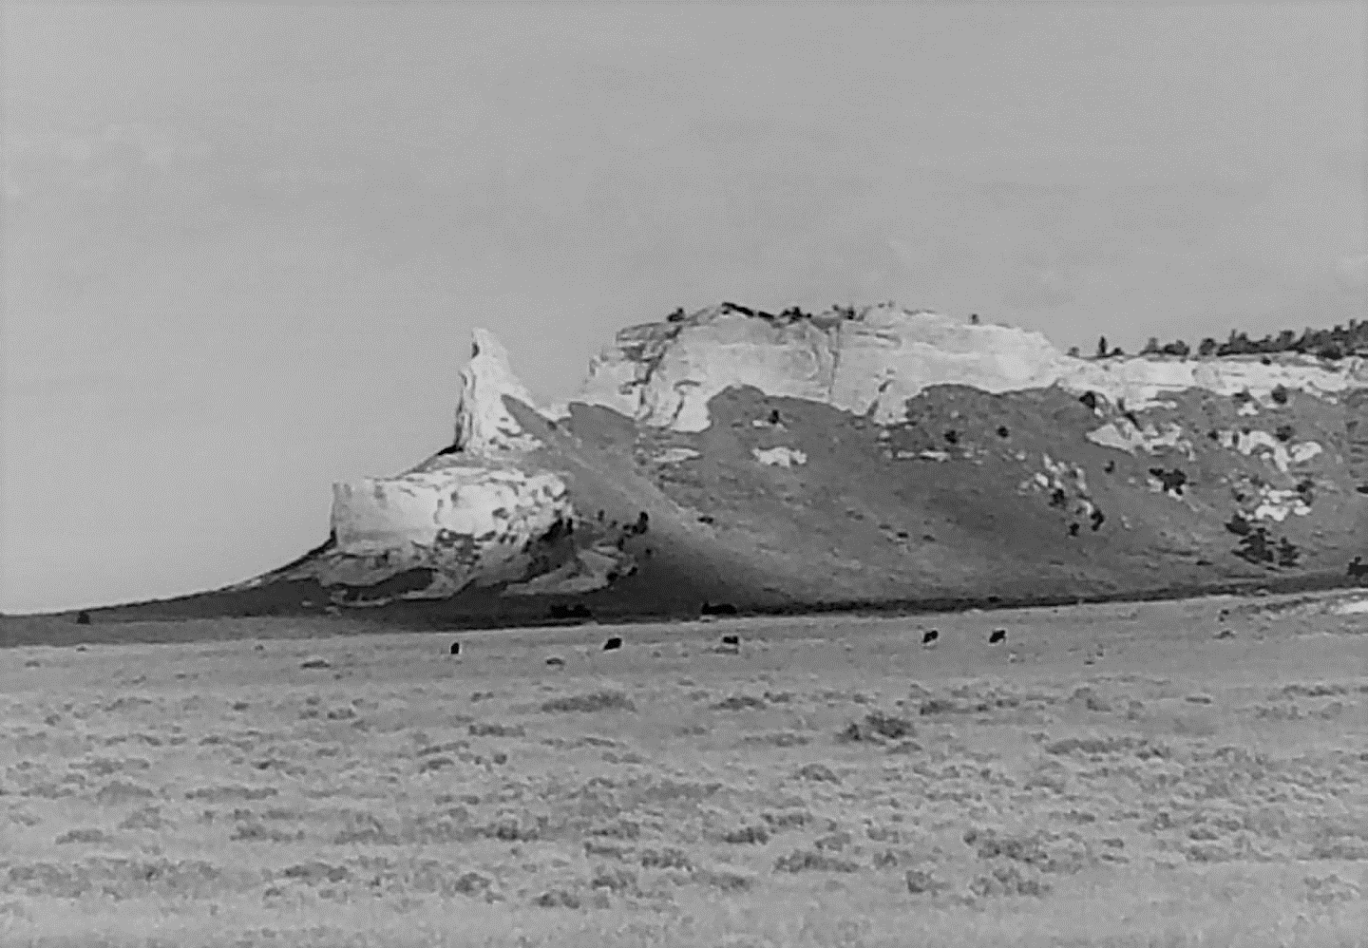
WILDCAT HILLS STOCKDOG CHALLENGE
3752 Hwy 88 West ~ Harrisburg, NE
July 11-14, 2019

Handler Name ________________________________________________________________
Address_____________________________________________________________________
City______________________________State_________Zip Code_______________________
Phone______________________________Email____________________________________
Open Class $75 per run
Dogs Name | July 11 Sheep | July 12 Sheep | July 13 Cattle | July 14 Cattle | Total
Open Ranch Class $60 per run
Dogs Name | July 11 Sheep | July 12 Sheep | July 13 Cattle | July 14 Cattle | Total
Nursery Class $75 per run
Dogs Name | July 11 Sheep | July 12 Sheep | July 13 Cattle | July 14 Cattle | Total
Checks made payable and mail to: Wild Cat Hills Stock Dog Challenge
Payment must accompany entry 3752 Hwy 88 west, Harrisburg, NE 69345 Total Enclosed____________
Contact: Tanya Williams (530) 227-1340 or WildcatHillsStockdog@gmail.com
If you would like to volunteer to scribe please check here_______
In consideration that my dog(s) and I will be participating in the above named stock dog trial, I understand that I am responsible for any and all costs incurred as a result of damages caused by myself, my family or my dog(s) to the facilities, animals and /or people. I hereby agree that in the event of personal injury or damage to myself, my property or animals, I will not hold the USBCHA, its members, sponsors, trial organizers, owners of livestock or other property owners responsible.
Signature________________________________________________________Date_____________________
OFFICE: Date rcvd_________________ Total$____________CK#____________Postmark________________

